Plan de Clase Colegio Soldados de la Cruz 2024
Fecha: 29/01/24 | Grado: 6th | Periodo: 9:20-10:00
Asignatura: Lengua Extranjera | Docente: Zeneyda Centeno
Competencia de Grado:
Show interest in knowing, protecting, and preserving the elements of natural heritage as part of the country´s wealth.

Unity: Diagnostical Test
Content: Places in the city
Evaluation Criteria: Identify the vocabulary about places in the city
Achievement Indicators: students practice by talking about places in your town
Strategies of learning: Speaking, Listening , writting and reading
Initial Activities :Greetings, praying , song, activities and values.
Development:

Solve the following definitions

1-place where you buy sweet frozen food ---------------------

2. place where you buy clothes ---------------------------------

3. place where you see people acting -----------------------

4. place where you wait the bus.-----------------------------

5.place where children play -----------------------------------

6.place where you buy mediciones------------------------------

7.place where tourists stay ------------------------------------

8.place where you buy bread ---------------------------------

9.place where you receive education ----------------------------

10. place where you pray to God ----------------------------------
Culmination: they respond the sentences
Evaluation: practical class

Plan de Clase Colegio Soldados de la Cruz 2024
Fecha: 30/012/24 | Grado:9th | Periodo:7:00 –8:20
Asignatura: Lengua Extranjera | Docente: Zeneyda Centeno
Competencia de Grado: - Interact with its natural, social and cultural environment in peaceful, responsible and respectful coexistence that allows to develop in an environment of peace and harmony
Unity: 1 : Diagnostical test
Content: the family modern and changing family
Evaluation Criteria: Refresh their knowledge
Achievement Indicators:the student will be able to make differences between the moder families and the changing families
Strategies of learning: Speaking, Listening , writting and reading
Initial Activities :Greetings, praying , song, activities and values.
Development:

Vocabulary: Match the words with their definitions

a) Parents 1.your mother or your father’s sister

b)Relatives 2.the end of a marriage

c) Cousin 3. A mother or father

d)Reunion 4.the child of your aunt and uncle

e) Divorce 5.people in your family

f) Aunt 6) a meeting of people after a long time

Culmination: they read a comprehension letter
Evaluation: practical class

Plan de Clase Colegio Soldados de la Cruz 2024
Fecha: 30/01/24 | Grado: 4th grado | Periodo:9:20-10:00
Asignatura: Lengua Extranjera | Docente: Zeneyda Centeno
Unity: Diagnostical test
Learning outcomes : Establish conversations confidently about festivals and celebrations in their community, city or country
Content: nouns
Evaluation Criteria:
Achievement Indicators: Students will be able to name nouns by telling about their favorite things, people, places or characters.
Strategies of learning: Speaking, Listening , writting and reading
Initial Activities :Greetings, praying , song, activities and values.

Development:
After all the drawings are handed to you. Pick 5 drawings that are interesting and showed the most effort in coloring and drawing. Ask them why it is their favorite thing. Ask others who want to share about their drawing to raise their hand and tell about it to the class.
Tell them that their favorite things have names. These names are words we call “nouns.”
Tell them that some things are countable while other are not, we call them uncountable nouns.
Give examples of countable nouns and give examples of how to quantify uncountable nouns.
Group students into two teams then each one would have their chance to tell if the flashcard showing things is countable or uncountable.

Animals
Things
People

Culmination: Ask students: What are nouns?
Evaluation :practical class.

Plan de Clase Colegio Soldados de la Cruz 2024
Fecha: 31/01/24 | Grado: 5to | Periodo: 7:00-7:40 8:20-9:00
Asignatura: A.E.P. | Docente: Zeneyda Centeno
N° y Nombre de la Unidad: 1 descubro y desarrollo mis talentos
Competencia de eje transversal:
Competencia de Grado: descubre talentos propios que le permita aplicarlos en el desarrollo de ideas emprendedoras en el ámbito científico y tegnologico
Indicador de logro: El estudiante será capaz de entender los conceptos de la disciplina A.E.P
Criterio de Evaluación: Lee y se documenta
Contenido: concepto de A.E.P
Iniciación : Saludos, oración,asistencia ,actividades y logros

Desarrollo:
Concepto de A.E.P
consiste en crear las condiciones para transformar las prácticas educativas, a fin de brindar un aprendizaje de calidad para niñas, niños, adolescentes, jóvenes y adultos, con una educación orientada a Aprender, Emprender, Prosperar

¿Que nos enseña la clase de AEP?
Cabe aclarar, que la asignatura AEP tiene como propósito guiar a los estudiantes en el proceso de realización de un proyecto creativo, el cual debe reflejar sus habilidades y destrezas, tanto de manera individual como colectiva.

Culminación:Reflexiona sobre los concepto
Asignación de tarea en casa: clase practica

Plan de Clase Colegio Soldados de la Cruz 2024
Fecha: 31/01/24 | Grado:5th | Periodo:9:20-10:00
Asignatura: Lengua Extranjera | Docente: Zeneyda Centeno
Competencia de Grado: - Interact with its natural, social and cultural environment in peaceful, responsible and respectful coexistence that allows to develop in an environment of peace and harmony
Unity: 1 : diagnostical test
Content: Nouns
Evaluation Criteria: the student practice the nouns
Achievement Indicators:
Strategies of learning: Speaking, Listening , writting and reading
Initial Activities :Greetings, praying , song, activities and values.
Development:
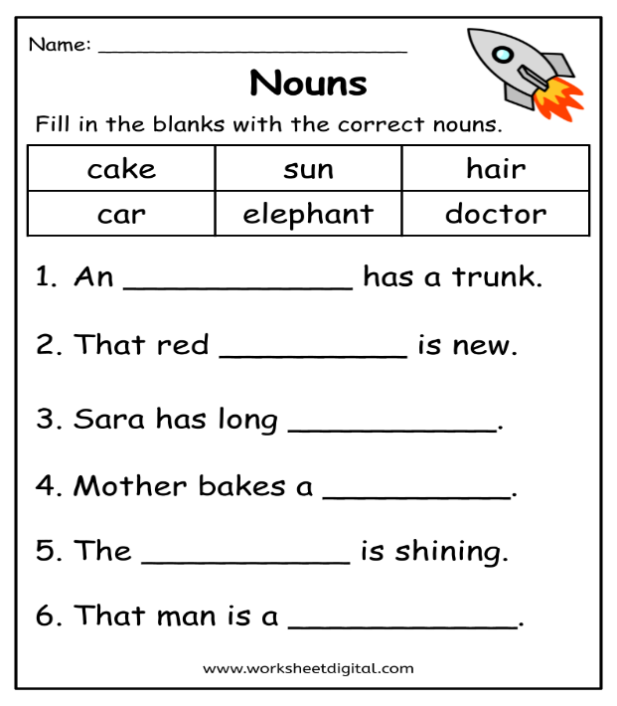
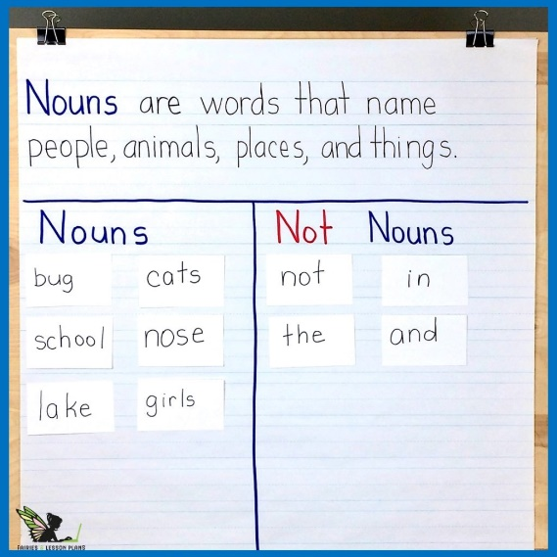
What is a nouns?

Culmination: they write the noun in their notebook
Evaluation: practical class

Plan de Clase Colegio Soldados de la Cruz 2024
Fecha: 01/02 /24 | Grado: 4th grado | Periodo:7:-7:40
Asignatura: Lengua Extranjera | Docente: Zeneyda Centeno
Unity: Diagnostical test
Learning outcomes : Establish conversations confidently about festivals and celebrations in their community, city or country
Content: nouns
Evaluation Criteria:
Achievement Indicators: Students will be able to name nouns by telling about their favorite things, people, places or characters.
Strategies of learning: Speaking, Listening , writting and reading
Initial Activities :Greetings, praying , song, activities and values.

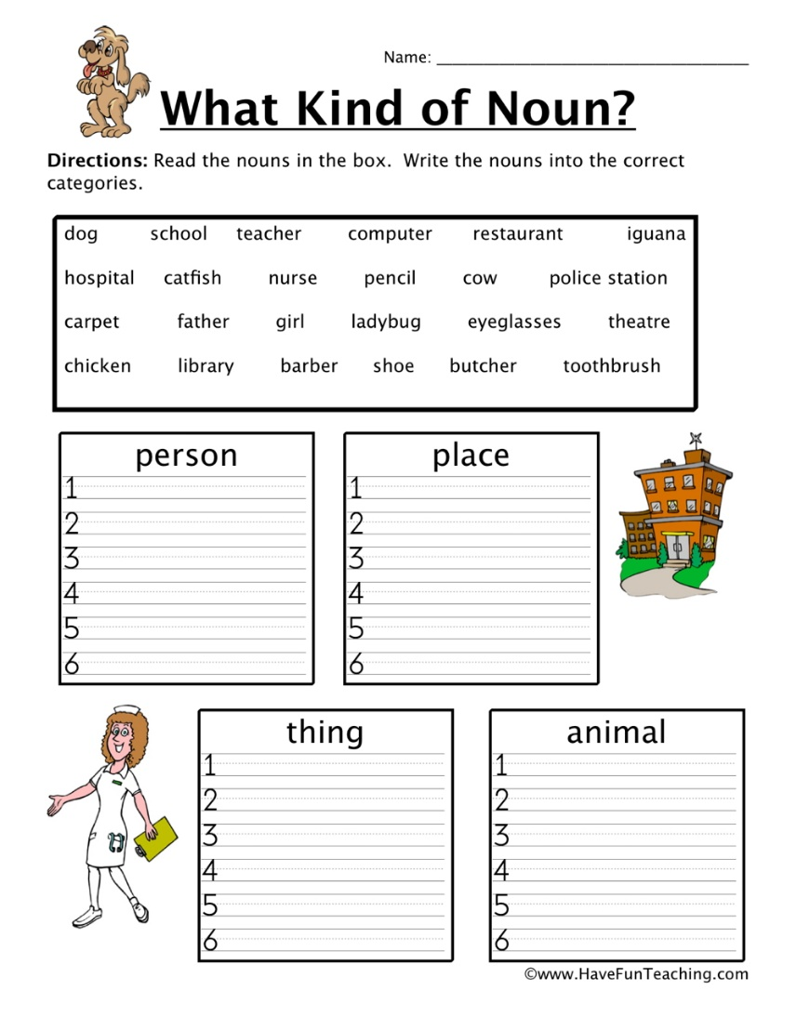
Development:
Culmination: Ask students: What are nouns?
Evaluation :practical class.

Plan de Clase Colegio Soldados de la Cruz 2024
Fecha: 01/02/24 | Grado: 6th | Periodo: 7:40-8:20
Asignatura: Lengua Extranjera | Docente: Zeneyda Centeno
Competencia de Grado:
Show interest in knowing, protecting, and preserving the elements of natural heritage as part of the country´s wealth.

Unity: Diagnostical Test
Content: Places in the city
Evaluation Criteria: Identify the vocabulary about places in the city
Achievement Indicators: students practice by talking about places in your town
Strategies of learning: Speaking, Listening , writting and reading
Initial Activities :Greetings, praying , song, activities and values.
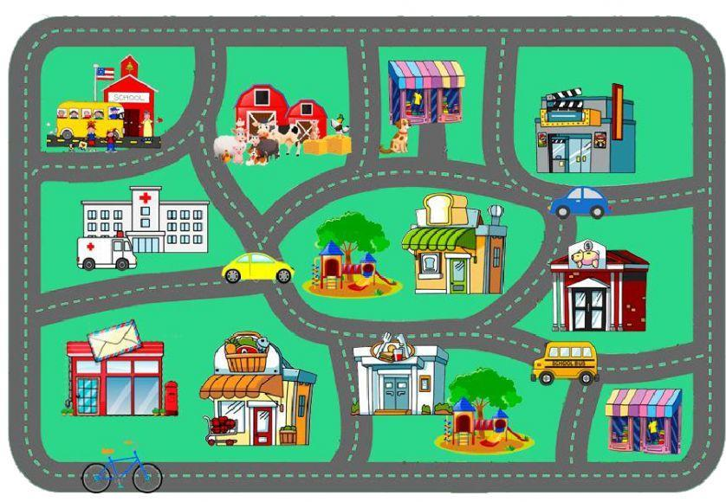
Development: Where is the Restaurant?
Culmination: they respond the sentences
Evaluation: practical class

Evaluation : practical class
plan de Clase Colegio Soldados de la Cruz 2024
Fecha: 01/02/24 | Grado: 5to | Periodo: 8:20-9:00
Asignatura: Creciendo en valores | Docente: Zeneyda Centeno
Unidad #1 : valores para el desarrollo y la sana convivencia
Competencia de eje transversal: practico valores para el desarrollo personal y la sana convivencia
Competencia de Grado: Muestra interés por la superación personal para mejorar su bienestar
fortalece su auto estima ,confianza y seguridad al respetarse asi mismo
Indicador de logro:muestra interés y motivación en las diferentes actividades que realiza

Criterio de Evaluación: Analiza la exponencia
C: Mis me quiero,me cuido ,me acepto alos demás
Iniciación: saludos ,oración, asistencia ,actividades y valores

Desarrollo:
La maestra reflexiona con su grupo de estudiantes, sobre los valores que debemos de tener en vuestros hogares.

Leemos la informacion en el libro en la página 18
Culminación: realizamos actividades de afianzamiento
Asignación de tarea en casa: clase practica

Plan de Clase Colegio Soldados de la Cruz 2024
Fecha: 02/02/24 | Grado: 7th grado | Periodo:8:20-9:00
Asignatura: Lengua Extranjera | Docente: Zeneyda Centeno
Competencia de Grado: Show interest in knowing, protecting, and preserving the elements of natural heritage as part of the country´s wealth.

Unity: 1 : diagnostical test
Content: family tree vocabulary
aluation Criteria: remember the vocabulary
Achievement Indicators: students practice by talking about different members of the family
Strategies of learning: Speaking, Listening , writting and reading
Initial Activities :Greetings, praying , song, activities and values.
Development: Do "Students' Family Photos Time" activity
If your students have brought in photos of themselves and their families, this is a great activity to do. If not, go to step 3.
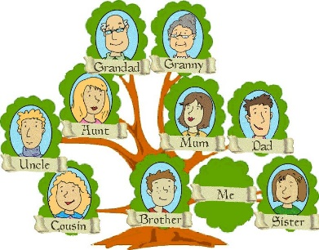
On the board, under the row of 7 photos of your family you are going to place photos from each of the students' families. First, hold up the photos of the students in your class and elicit who they are - each time, stick their photo in the middle column and write their names underneath

Culmination: the student make their family tree
Evaluation : practical class

plan de Clase Colegio Soldados de la Cruz 2024
Fecha: 02/02/24 | Grado:6to | Periodo: 9:20-10:00
Asignatura: Creciendo en valores | Docente: Zeneyda Centeno
Unidad #1 : valores para el desarrollo y la sana convivencia
Competencia de eje transversal: practico valores para el desarrollo personal y la sana convivencia
Competencia de Grado: Muestra interés por la superación personal para mejorar su bienestar
fortalece su auto estima ,confianza y seguridad al respetarse asi mismo
Indicador de logro:muestra interés y motivación en las diferentes actividades que realiza

Criterio de Evaluación: Analiza la exponencia
C: Mis me quiero,me cuido ,me acepto alos demás
Iniciación: saludos ,oración, asistencia ,actividades y valores

Desarrollo:
La maestra reflexiona con su grupo de estudiantes, sobre los valores que debemos de tener en vuestros hogares.

Leemos la informacion en el libro en la página 18
Culminación: realizamos actividades de afianzamiento
Asignación de tarea en casa: clase practica

