Plan de Clase Colegio Soldados de la Cruz 2024
Fecha: 19/02/24 | Grado: 6th grado | Periodo:9:20-10:40
Asignatura: Lengua Extranjera | Docente: Zeneyda Centeno
Competencia de Grado:
Unity: 1 : family ,school, community and country
Content: preposition of place
Evaluation Criteria: Recognizes concepts and definitions related to tourism in panamá.
Achievement Indicators:Identify places on the city map
Strategies of learning: Speaking, Listening , writting and reading
Initial Activities :Greetings, praying , song, activities and values.
Development:
Prepositions of place are words such as on, in, under, in front of, behind, next to, between, etc. A preposition of place is used to refer to the location of something or someone.
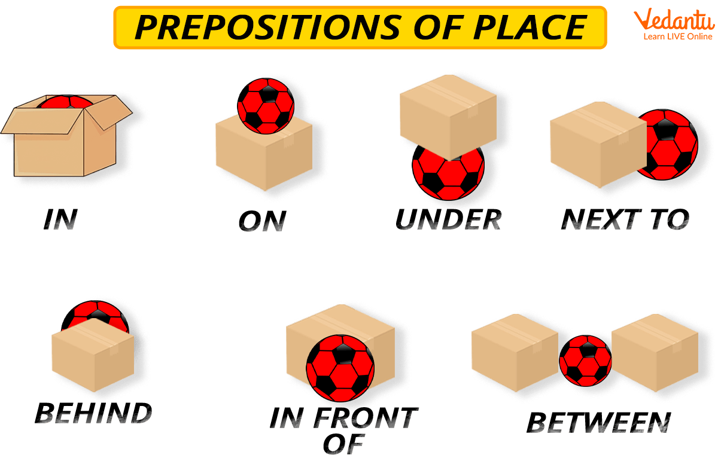

We write the spanish meaning of every preposition.

Where is the church .? Where is the park? Where is the school?

Where is the bank? Where is the post office?
Culmination: the student look at the map and answer the question
Evaluation : student book page #22: choose the correct preposition

Plan de Clase Colegio Soldados de la Cruz 2024
Fecha: 19/02/24 | Grado: 7th | Periodo: 10:40-11:50
Asignatura: Lengua Extranjera | Docente: Zeneyda Centeno
Competencia de Grado: The student interprets simple texts in simple present and past
Unity: 1 : family ,school, community and country
Content: Family Members
Evaluation Criteria: Asks and answers personal information, about their family in shorts dialogue with their classmate
Achievement Indicators:The student practice the vocabulary about their family members.
Strategies of learning: Speaking, Listening , writting and reading
Initial Activities :Greetings, praying , song, activities and values.
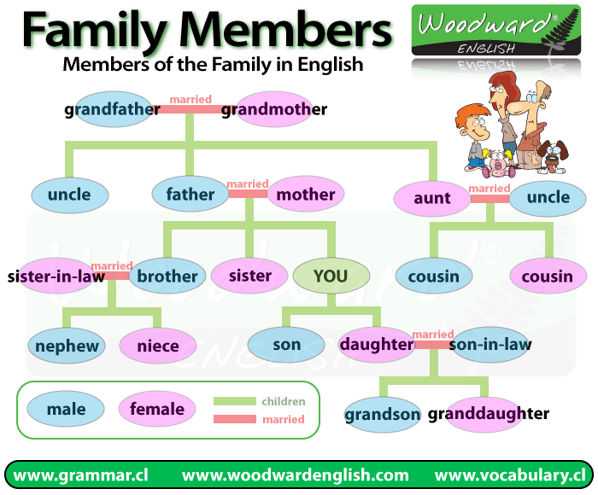
Development:
Write a list of things that each person in your house does .

Family Member Inside the house outside the house
Culmination: family activities
Evaluation: the family trees from every student pag# 10

Plan de Clase Colegio Soldados de la Cruz 2024
Fecha: 20/02/24 | Grado:9th | Periodo:7:00 –8:20
Asignatura: Lengua Extranjera | Docente: Zeneyda Centeno
Competencia de Grado: - Interact with its natural, social and cultural environment in peaceful, responsible and respectful coexistence that allows to develop in an environment of peace and harmony
Unity: 1 : family ,school, community and country
Content: verb to be
Evaluation Criteria: Identifies and learn at least the 4 skills to know with the verb to be
Achievement Indicators:the students will be able to make sentences using the verb to be
Strategies of learning: Speaking, Listening , writting and reading
Initial Activities :Greetings, praying , song, activities and values.
Development:
We can use the present simple of the verb to be to talk about situations and states in the present

I am ten years old. They are Egyptian. My mum is a doctor.

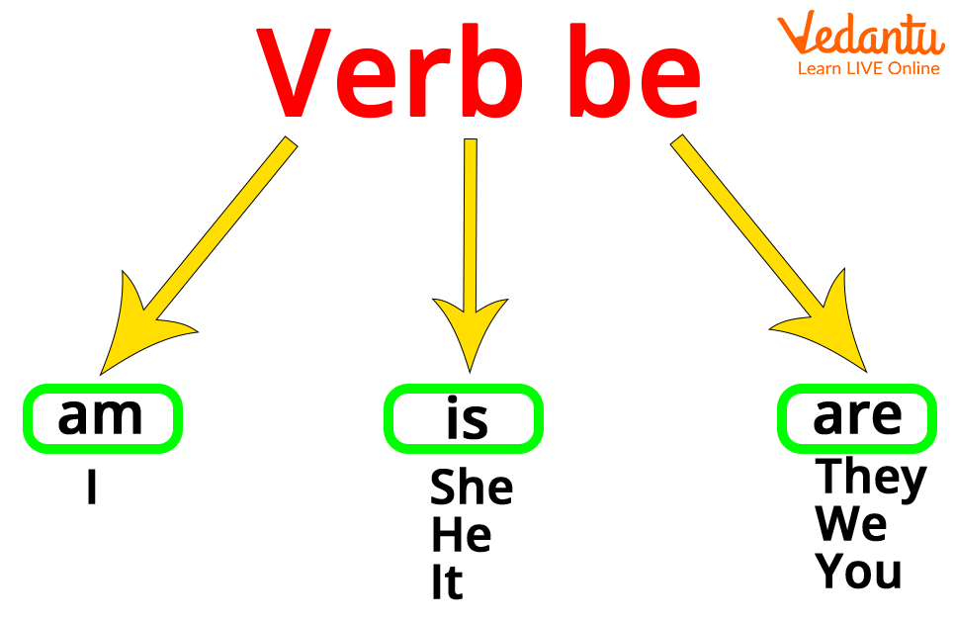

Culmination: make sentences using the verb to be
Evaluation: practical class pag# 12

Plan de Clase Colegio Soldados de la Cruz 2024
Fecha: 20/02/24 | Grado: 4th grado | Periodo:9:20-10:40
Asignatura: Lengua Extranjera | Docente: Zeneyda Centeno
Unity: 1 : family ,school, community and country
Learning outcomes : Establish conversations confidently about festivals and celebrations in their community, city or country
Content: Comparative and supperlative adjectives
Evaluation Criteria: the students practice comparing 2 things using comparative adjectives.
Achievement Indicators:students practice using common adjectives to describe objects and then make comparisons using comparative adjectives.
Strategies of learning: Speaking, Listening , writting and reading
Initial Activities :Greetings, praying , song, activities and values.

Development: What are comparative adjectives?
A comparative adjective compares differences between two nouns.
Comparatives take the following forms:

the adj+er: in most cases, adjectives with 1 or 2 syllables take the “er” form (e.g. fast – faster / heavy – heavier)
the more + adj: in most cases, adjectives with 3 or more syllables take the “more ~” form (e.g. expensive – more expensive / beautiful – more beautiful)
there are a few exceptions to the above rule (e.g. modern – more modern)
irregular forms: “good” and “bad” take the irregular forms “better” / “worse”
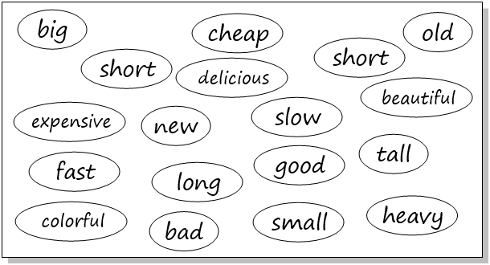

Culmination: the student described to their classmate
Evaluation :practical class.

Plan de Clase Colegio Soldados de la Cruz 2024
Fecha: 20/02/24 | Grado:5th | Periodo:9:20-10:40
Asignatura: Lengua Extranjera | Docente: Zeneyda Centeno
Competencia de Grado: - Interact with its natural, social and cultural environment in peaceful, responsible and respectful coexistence that allows to develop in an environment of peace and harmony
Unity: 1 : family ,school, community and country
Content: there is and there are
Evaluation Criteria: speaking the lesson
Achievement Indicators: the students will have been presented and practiced "there is and there are" in
the context of places in the city.
Strategies of learning: Speaking, Listening , writting and reading
Initial Activities :Greetings, praying , song, activities and values.
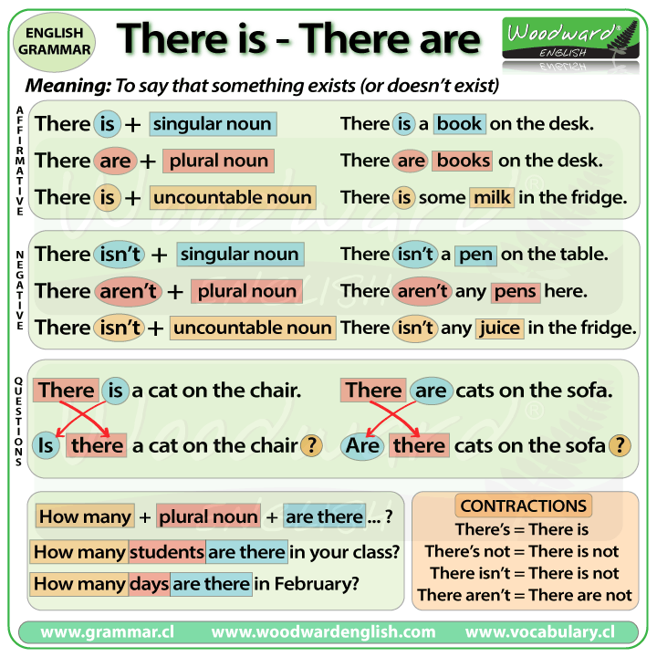
Development:

Culmination: the worked wiyth their classmate
Evaluation: practical class 21 Activity 8
Plan de Clase Colegio Soldados de la Cruz 2024
Fecha: 21/02/24 | Grado: 5to | Periodo: 7:00-8:20
Asignatura: A.E.P. | Docente: Zeneyda Centeno
N° y Nombre de la Unidad: 1 descubro y desarrollo mis talentos
Competencia de eje transversal:
Competencia de Grado: demuestra una actitudn creativa e innovadora al proponer y desarrollar sus ideas emprendedoras en el ámbito social,cultural ,ambiental, deportivo ,científico e tecnológico,contribuyendo a la calidad de vida personal ,familiar ,escolar, comunitaria y socioeconomico
Indicador de logro: identifica sus talentos demostrando autonomía ,entusiasmo, y creatividad en el ámbito científico y tecnologico
Criterio de Evaluación: demuestra respeto por sus compañeros de clase
Contenido: El talento
Iniciación : Exploracion de conocimientos previos
a) que significa para ti la palabra Talento?

b) Que cosas sabes hacer?

Analizamos el concepto de la palabra talento.

Desarrollo:

Nos ubicamos en la # pagina #9 y analicemos como y cuáles son las característica del talento

Culminación: investiga en tu familia quienes se han destacado por sus talentos y lo presenta a la clase

Asignación de tarea en casa: clase practica

Plan de Clase Colegio Soldados de la Cruz 2024
Fecha: 21/02/24 | Grado:5th | Periodo:9:20—10:40
Asignatura: Lengua Extranjera | Docente: Zeneyda Centeno
Competencia de Grado: - Interact with its natural, social and cultural environment in peaceful, responsible and respectful coexistence that allows to develop in an environment of peace and harmony
Unity: 1 : family ,school, community and country
Content: there is and there are
Evaluation Criteria: speaking the lesson
Achievement Indicators: the students will have been presented and practiced "there is and there are" in
the context of places in the city.
Strategies of learning: Speaking, Listening , writting and reading
Initial Activities :Greetings, praying , song, activities and values.
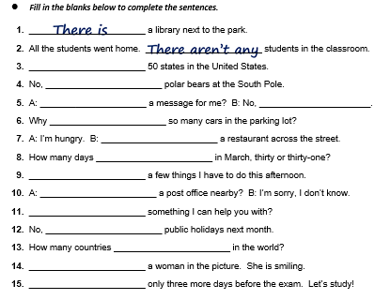
Development:

Culmination: the worked wiyth their classmate
Evaluation: practical class 21 Activity 8

Plan de Clase Colegio Soldados de la Cruz 2024
Fecha: 22/02/24 | Grado: 4th grado | Periodo:7:00-7:40
Asignatura: Lengua Extranjera | Docente: Zeneyda Centeno
Unity: 1 : family ,school, community and country
Learning outcomes : Establish conversations confidently about festivals and celebrations in their community, city or country
Content: Comparative and supperlative adjectives
Evaluation Criteria: the students practice comparing 2 things using comparative adjectives.
Achievement Indicators:students practice using common adjectives to describe objects and then make comparisons using comparative adjectives.
Strategies of learning: Speaking, Listening , writting and reading
Initial Activities :Greetings, praying , song, activities and values.

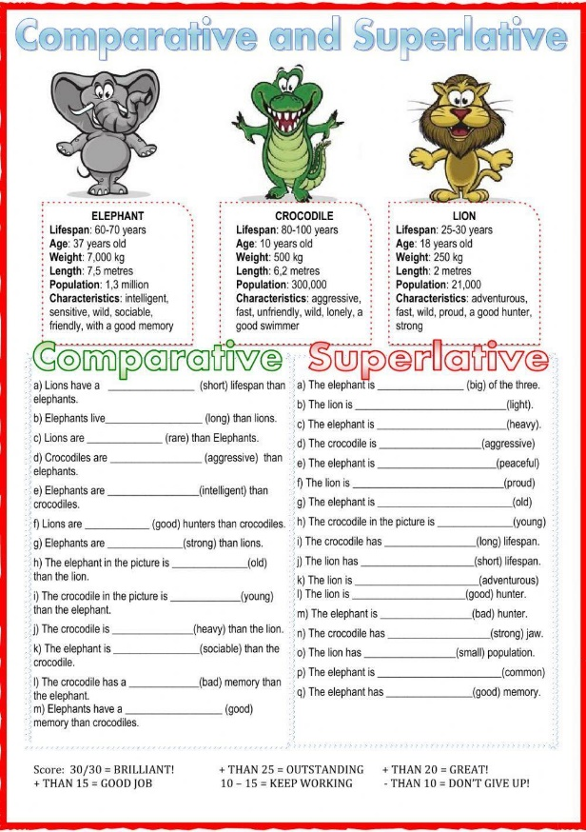
Developmen

Culmination: the student compare to their classmate
Evaluation :practical class.

Plan de Clase Colegio Soldados de la Cruz 2024
Fecha: 22/02/24 | Grado: 6th grado | Periodo:9:20-10:40
Asignatura: Lengua Extranjera | Docente: Zeneyda Centeno
Competencia de Grado:
Unity: 1 : family ,school, community and country
Content: preposition of place
Evaluation Criteria: Recognizes concepts and definitions related to tourism in panamá.
Achievement Indicators:Identify places on the city map
Strategies of learning: Speaking, Listening , writting and reading
Initial Activities :Greetings, praying , song, activities and values.
Development:
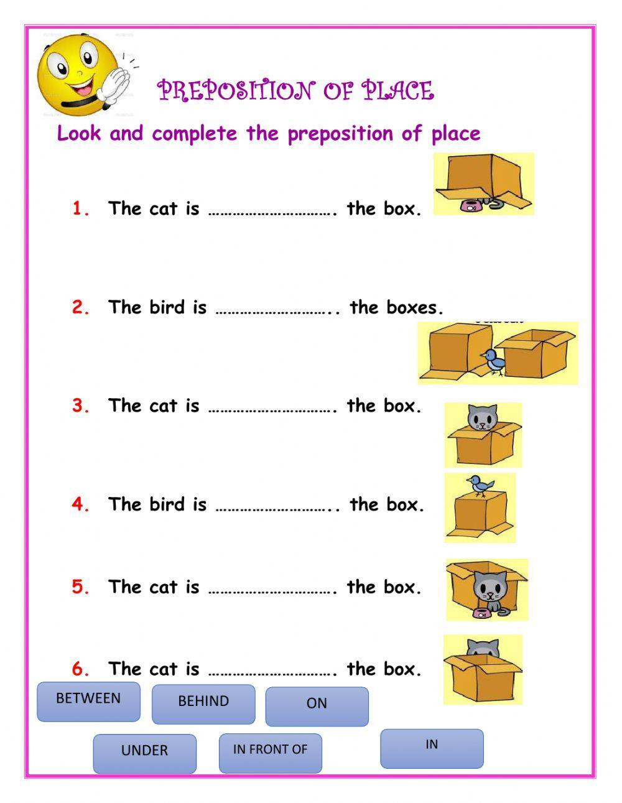
Prepositions of place are words such as on, in, under, in front of, behind, next to, between, etc. A preposition of place is used to refer to the location of something or someone.

Culmination: the student look at the map and answer the question
Evaluation : student book page #22: choose the correct preposition

Plan de Clase Colegio Soldados de la Cruz 2024
Fecha: 22/02/24 | Grado: 5to | Periodo: 8:20-9:00
Asignatura: Creciendo en valores | Docente: Zeneyda Centeno
Unidad #1 : valores para el desarrollo y la sana convivencia
Competencia de eje transversal: practico valores para el desarrollo personal y la sana convivencia
Competencia de Grado: Demuestra confianza y seguridad en sí mismo, reconociendo sus
características personales para aceptarse, respetarse, quererse y
cuidarse para sentirse bien consigo mismo/a y con las demás
persona
fortalece su auto estima ,confianza y seguridad al respetarse asi mismo
Indicador de logro: Demuestra afecto al respetarse y cuidarse a sí mismo

Criterio de Evaluación: Analiza la exponencia
C: Me quiero,me cuido,me acepto y acepto a los demás
Iniciación: saludos ,oración, asistencia ,actividades y valores

Desarrollo:
Actividad 1: Frente al espejo
✓ Oriento la actividad que se persigue para mejorar el autoconcepto de cada uno de ellos. Llevo a clases un espejo, organizados en un
círculo pide se sienten cómodamente ya sea en su pupitre o piso de su aula.
✓ Solicito mirarse en un espejo, y a través de una serie de preguntas realice una reflexión y exprese cuál es su opinión sobre ello:
• ¿Cuándo te miras en el espejo te ves guapo/a?
• ¿Piensas que tienes cosas buenas que aportar a los demás? ¿Cuáles?
• ¿Crees que les gustas a tus amigos y compañeros tal y como eres?
• ¿Qué cambiarias de tu apariencia?
• ¿Cuándo te sientes y te ves bien, te sientes más seguro de ti mismo?
✓ Una vez que ha logrado que los estudiantes cuenten su punto de vista sobre estos aspectos, se les pide que se miren de nuevo al
espejo.
✓ Se les pide ponerse de pie y situar el espejo a la altura de cada uno de ellos y responde las siguientes preguntas:

Culminación: como me valoro

Asignación de tarea en casa: clase practica

Plan de Clase Colegio Soldados de la Cruz 2024
Fecha: 20/02/24 | Grado:9th | Periodo:10:-10:40
Asignatura: Lengua Extranjera | Docente: Zeneyda Centeno
Competencia de Grado: - Interact with its natural, social and cultural environment in peaceful, responsible and respectful coexistence that allows to develop in an environment of peace and harmony
Unity: 1 : family ,school, community and country
Content: verb to be
Evaluation Criteria: Identifies and learn at least the 4 skills to know with the verb to be
Achievement Indicators:the students will be able to make sentences using the verb to be
Strategies of learning: Speaking, Listening , writting and reading
Initial Activities :Greetings, praying , song, activities and values.
Development:
We can use the present simple of the verb to be to talk about situations and states in the present

Complete the sentences with the forms of to be in the present simple (am, is, are).
1. I at home.
2. She not at home in the morning.
3. We in the park.
4. This my new laptop.
5. Our friends on their summer holidays.
6. Uncle George a good football player.
7. The dog under the table.
8. He very funny.
9. The shoes white.
10. You right.
11. Susan good at tennis.
12. They in the house.
13. His T-shirts cool.
14. My sister a good swimmer.
15. She in Italy.

Culmination: make sentences using the verb to be
Evaluation: practical class

Plan de Clase Colegio Soldados de la Cruz 2024
Fecha: 19/02/24 | Grado: 7th | Periodo: 10:40-11:50
Asignatura: Lengua Extranjera | Docente: Zeneyda Centeno
Competencia de Grado:
Unity: 1 : family ,school, community and country
Content: the verb to be
Evaluation Criteria: to express their feeling using the verb be
Achievement Indicators: the students will be able to make sentences using the verb be correctly
Strategies of learning: Speaking, Listening , writting and reading
Initial Activities :Greetings, praying , song, activities and values.
Development:
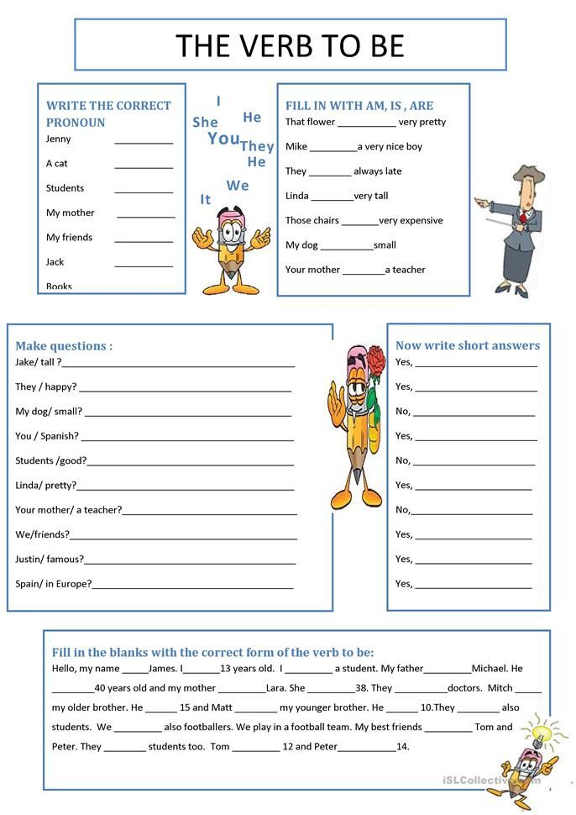
Write a list of things that each person in your house does .

Culmination: learning how to use the verb to be
Evaluation: practical class

